**KABOJJA JUNIOR SCHOOL**

**P.1 R.E MID – TERM EXAMS I, 2024**

**Time Allowed: 2hrs 30 minutes**

**NAME**: ……………………………………………………………………………………………………………………….

**DISTRICT:** …………………………………………………… **CLASS:** ……………………………………….

1. Who created you?

_______________________________________________________

2. Write your religious name.

_______________________________________________________

3. **Circle the Christian name for boys**.

John Juma peter

Abraham Moses Ibra

4. **Tick ( ) the Moslem names for girls**.

Sarah hanifah prossy

Mary shamim joan

5. **Match correctly**.

Jesus mankind

Peter thief

Jacob saviour

Adam Rock

6. Muslims go to the ________________pray.

(Church, mosque)

7. Christians go to pray on ________________(Friday, Sunday)

8. **Circle the Christian names for girls**.

Mary Fatumah Grace Faith Alice

Aisha

9. **Read and draw.**

eyes nose fingers head

leg ears

10. **Match body organs to their senses**.

nose seeing

ears tasting

eyes smelling

tongue hearing

11. **Tick ways of cleaning our bodies**.

running bathing brushing

writing well sitting down combing hair

crying so much washing clothes cutting nails.

12. Muslims read _________________(quran, bible)

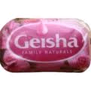13. Name these things used to clean our bodies.

________________ _________________

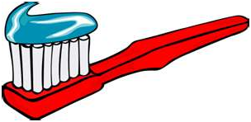

__________________

14. **Complete these sentences correctly**.

a. Eyes are for ___________________________________________

b. Ears are for ___________________________________________

c. The _____________is used for smelling.

d. ________________are for walking.

e. The mouth is for ___________________

f. The _________________is for tasting.

hearing nose seeing tongue legs

talking

15. **Circle the correct word**.

good God odg

head haed hade

era rae ear

seno seno nose

bibo Bible bible

gel elg leg

16.Muslims go for Juma prayers on _______________________________________________________

(Friday, Sunday)